# **Spring Boot CRUD Application**

**Description: This project created in the aim of to provide online books service provider with spring boot and restful API to represent all CRUD operation.**

# Pre-Requirements:

1. Java 1.8 or Higher Version
2. STS Tool (Spring Tool Suite)
3. MySQL Data Base
4. MySQL Workbench
5. Post man (Test tool)

# Spring Boot Project Creation:

We can create Spring Boot application using Spring initializer <https://start.spring.io/>

Steps:

1. Select from the fields below from the spring initializer.

* Project: Maven
* Language: Java
* Spring Boot: 3.4.3 or latest version
* Project Metadata: As per our project related naming conventions, we should provide details like group, artifact, name etc.
* Packaging: jar with java 17
* Dependence: Add the below dependency starters
* spring-boot-starter-web,
* spring-boot-starter-security,
* spring-boot-starter-data-jpa
* mysql-connector-j

1. After clicking Generate then download the zip folder and extract and import as maven existing project into STS workspace.

# MySQL Database Download And Installation

**1. Download MySQL Installer**

1. Go to the **MySQL official website**:  
   <https://dev.mysql.com/downloads/installer/>
2. Click on **Windows** to download the installer. You will have two options:
   * **MySQL Installer (web)**: This is a smaller download (around 2 MB) and downloads the necessary components during installation.
   * **MySQL Installer (full)**: This is a larger download (around 400 MB) and contains all the MySQL components, so you don't need an internet connection during installation.

For most users, the **MySQL Installer (web)** is fine.

1. Click on the **Download** button and choose either the **"Windows (x86, 32-bit), MSI Installer"** or **"Windows (x86, 64-bit), MSI Installer"**, depending on your Windows version.

**2. Run the Installer**

1. Once the installer is downloaded, open the file (mysql-installer-web-community-x.x.x.x.msi).
2. The **MySQL Installer** will start. It will show a screen with multiple installation options.

**3. Choose Setup Type**

* You can choose from four setup types:
  + **Developer Default**: Installs MySQL Server, MySQL Workbench, MySQL Shell, connectors, etc. (recommended for most users).
  + **Server Only**: Installs only MySQL Server.
  + **Client Only**: Installs only client programs like MySQL Workbench.
  + **Full**: Installs all MySQL products.

For a typical installation, select **Developer Default**.

**4. Install Prerequisites**

* The installer will check if your system meets the prerequisites. If anything is missing (like Visual C++ Redistributables), it will prompt you to install them. Follow the on-screen instructions to install any required components.

**5. Choose MySQL Products to Install**

* After the prerequisites are satisfied, you’ll see a list of products. Select the default MySQL Server and any other tools you need (like MySQL Workbench, MySQL Shell, etc.).

**Recommended**: Keep the default selections for MySQL Server and MySQL Workbench.

**6. Installation Process**

* The installer will now download and install MySQL Server and other components. This may take a few minutes depending on your internet speed and system performance.

**7. Configure MySQL Server**

* After installation, you will need to configure the MySQL Server. The configuration steps will guide you through:
  1. **Server Configuration Type**: Choose "Standalone MySQL Server" (unless you're setting up a cluster).
  2. **Authentication Method**: You can choose the default authentication method (recommended) or another one if needed. The default is "Use Strong Password Encryption."
  3. **Set the Root Password**: Set a strong password for the root MySQL user. You will need this password to access the MySQL server.
  4. **Configure MySQL as a Windows Service**: You can set MySQL to run as a Windows service so that it starts automatically when the system boots. The default is typically fine, so leave it as it is.
  5. **Port Number**: By default, MySQL uses port 3306. If you don’t have any port conflicts, leave it as it is.
  6. **Advanced Options**: You can configure advanced options like memory settings, file paths, etc. For most users, the default settings are fine.

After configuring, click **Next**.

**8. Start the MySQL Server**

* The installer will ask if you want to start the MySQL server now. Select **Start MySQL Server**.

**9. Finish the Installation**

* After configuring the server, the installer will complete the setup and display a summary. Click **Next** to finish the installation process.
* You can also choose to launch **MySQL Workbench**, which is a graphical tool for managing MySQL databases, or **MySQL Shell** for command-line operations.

**10. Test the Installation**

1. Open **MySQL Workbench** (if installed) or **Command Prompt**.
2. In the **MySQL Command Line Client**, type the following command to log in:

bash

Copy

mysql -u root -p

1. Enter the **root password** you set during the installation process.

If the installation was successful, you should now be logged into the MySQL server and can begin working with MySQL databases.

# Create package inside project explore

**Controller package:** To implement all crud operations like POST, GET, PUT, DELETE etc.

**Service package:** To implement business logic

**Dao package:** To implement database logic.

**Entity package:** To represent the whole request and response object

**Repository package:** To make connection between spring boot and MySQL database

# Spring Security implantation:

Spring security is the default basic authentication for this we need to provide the spring security starter dependency as mentioned below.

Step 1:

Step 2: By default, authentication credentials as username: user and password: < It will automatically generate once we start the application need to copy from STS console>.

Step: If we want to our customized credentials, we need to change the application.properties file with below details.

spring.security.user.name=****

spring.security.user.password=***

# POST MAN Testing

Using POST man tool we can test all our crud operators like POST, GET, PUT and DELETE

1. **POST OPERATION** (@PostMapping("books"))

**End Point URL:** <http://localhost:8080/bookservice/books>

**Request Payload/Request Body:** Json format with post method

**Response Payload:** In Json format with 200 success code

1. **GET OPERATION (**@GetMapping("books"))

**Endpoint URL:** <http://localhost:8080/bookservice/books> (To fetch all books)

**Request Payload/Request Body:** NA

**Response Payload:** Json Format with list of books

* 1. **GET OPERATION By Id (**@GetMapping("books/{id}"))

**Endpoint URL:** <http://localhost:8080/bookservice/books/353> (To fetch single books with book Id)

**Request Payload/Request Body:** NA

**Response Payload:** Joson response payload with single book details with 200 status code

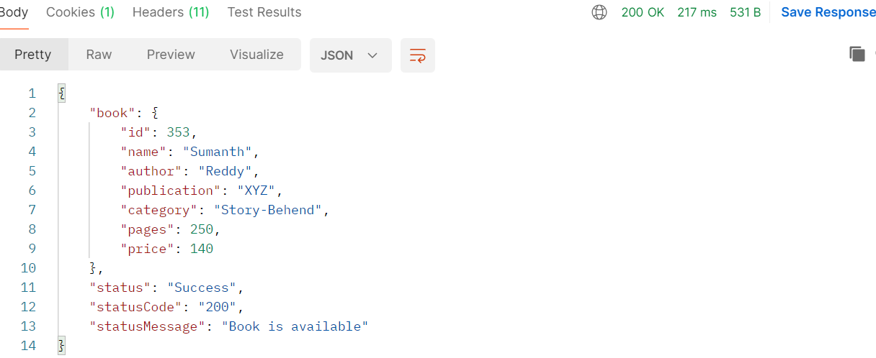

1. **PUT OPERATION (**@PutMapping("books/{id}"))

**Endpoint URL:** [**http://localhost:8080/bookservice/books/353**](http://localhost:8080/bookservice/books/353)It is used to update the existing resource or object with full or partial data.

**Request Payload/Request Body:** Json format with changed properties

**Response Payload:**

1. **DELETE OPERATION** (@DeleteMapping("books/{id}")**)**

**Endpoint URL:** http://localhost:8080/bookservice/books/354It is used to delete the existing resource or object with full or partial data.

**Request Payload/Request Body:** Json format with changed properties

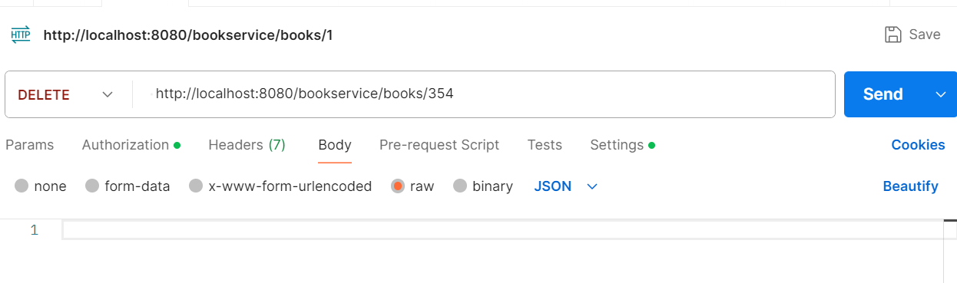

**Response Payload:**

